Edna E. (Durr) Strickler
April 8, 1895 – August 27, 1957

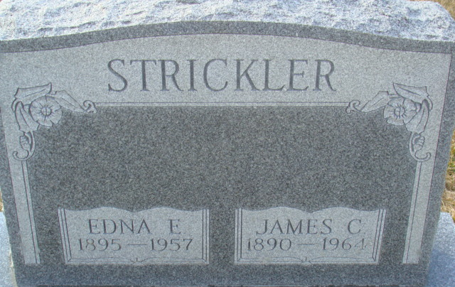
Photo by Alicia Kneuss

Edna Strickler Is Victim of Death - Coronary Fatal To Local Woman
Mrs. Edna E. Strickler, 62, a native and lifelong resident of this community died at the Adams County Memorial Hospital, at 1 a.m. today. She suffered a coronary occlusion at home late Monday evening, and was taken to the local hospital shortly after. Mrs. Strickler had been in ill health for the past several years, and her condition was regarded as serious for the past three months.
Born in Adams County April 8, 1895, she was the youngest daughter of Henry and Matilda Hurless-Durr. She was married to James C. Strickler, June 15, 1912. The couple has resided at 117 Porter Vista, for the past 10 years.
Mrs. Strickler was a member of the First Baptist Church, its Missionary Society, and the Philathea Sunday School class.
Surviving besides the husband, James. C., a longtime employee of the Decatur Casting Co., are three sons, Harold, Gerald and James. J., all of Decatur; a sister, Mrs. Goldie Hilyard, also of Decatur; a brother, Forrest Durr, of near Decatur, and seven grandchildren. One grandson is deceased.
Funeral services will be held Friday afternoon at 2 o’clock at the First Baptist Church, with the Rev. Stuart Brightwell officiating. Friends may call at the Black’s Funeral Home after 7 p.m. this evening, until noon Friday, when the body will be taken to the church, where it will lie in state until time of the services. Interment will be in the Decatur Cemetery.

Adams County Historical Museum, Adams County, Indiana
March 1955 – April 1958 Scrapbook, image 118
Handwritten date: Tuesday, August 27, 1957

