Donald E. Strickler
September 1, 1936 – March 24, 2017

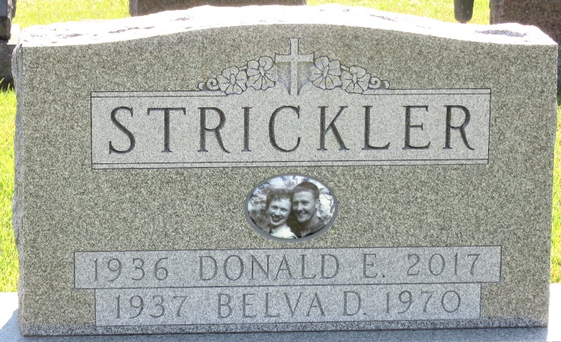
Photo by Barbara Baker Anderson

Don E. Strickler, 80, of Decatur, Indiana passed away at his residence on Friday, March 24, 2017. He was born in Willshire, Ohio to the late Kenneth "Roy" and Bertha "Bert" (Yager) Strickler on September 1, 1936.
He was first married to Belva Miller, she preceded him in death in October 1970. On May 2, 1975, he married Kaye Nern.
He served his country in the United States Marine Corp. He retired in 1994 from B.F. Goodrich after 28 years of service. He was a member of the American Legion Post #43, V.F.W., Moose Lodge 1311 and the Eagles Lodge.
Don loved IU Basketball, bowling and cooking as his family says he cooked a mean steak.
He is survived by his wife of 41 years, Kaye; 2 sons Mike (Robin) Strickler and Ron (Beth) Bedwell both of Decatur, IN; one daughter, Deb Strickler of Jeffersonville, IN; a sister, Barbara Carroll of Lima, OH; 5 grandchildren and 7 great grandchildren. Don was preceded in death by 2 brothers, Vic and Danny Strickler and a sister, Phyllis Shoaf.
Visitation will be held on Wednesday, March 29, 2017 from 2:00 to 6:00 p.m., at Haggard-Sefton & Hirschy Funeral Home. A Moose Memorial Service will be held at 6:00 p.m. on Wednesday, March 29, followed by a Funeral Service with Rev. Rusty Strickler officiating, concluding with Military Rites by American Legion Post #43 at the Funeral Home.

Haggard & Sefton Funeral Home, Adams County, Indiana
March 25, 2017

