Clarence W. Stricker
June 21, 1905 – February 13, 1984

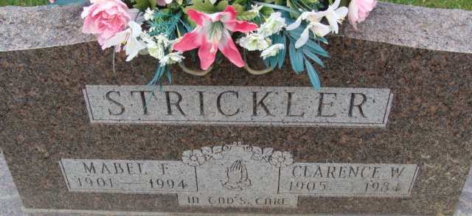
Photo by Alicia Kneuss

Funeral services for Clarence W Strickler, 78, 322 Bollman St., will be held Saturday at 10 a.m. at the Decatur Church of God with Rev. Kenneth J Mishler officiating. Burial will be in the Decatur Cemetery. Friends may call at the Winteregg-Linn Funeral Home from 7-9 p.m. and 2 to 5 and 7 to 9 p.m. Friday. The body will be in state at the church one hour prior to services.
Memorials are to the Decatur Church of God and Tape Ministries.
Mr. Strickler, who was active in the affairs of the Republican party and a former precinct committeeman, died unexpectedly at 10:10 p.m. Monday at L. W. Blake Hospital, Bradenton, FL.
He was a retired International Harvester Co. Supervisor, leaving there in 1966. He was a member of the Decatur Church of God and the Decatur Cemetery Board.
Born in Decatur on 21 June 1905, he was the son of C Gilbert and Golda Shoaf-Strickler, and was married 12 December 1926, to Mabel Dunifon who survives.
Also surviving are two children, Mrs. Kenneth (Bonnie) Watkins, Decatur, and Larry L. Strickler, Payne, OH; two brothers, Robert G. Strickler, Decatur, and Paul E Strickler, route 3 Decatur; four grandchildren and one great-grandchild.
One daughter Kathleen preceded him in death.

Decatur Daily Democrat, Adams County, Indiana
February 15, 1984

**
Florida, U.S., Death Index, 1877-1998
Name Clarence W Strickler
Race White
Age at Death 78
Birth Date 21 Jun 1905
Death Date 13 Feb 1984
Death Place Manatee, Florida, United States

