Clarence Gilbert Stricker
October 7, 1882 – April 21, 1966

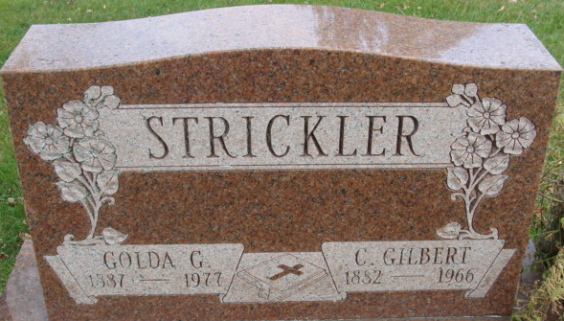
Photo by Alicia Kneuss

GILBERT STRICKLER DIES LAST EVENING
C. Gilbert Strickler, 83, of 743 Mercer avenue, well known Decatur resident, died at 6 o'clock Thursday evening at the Adams County Memorial Hospital, following an extended illness.
Mr. Strickler had retired after 27 years as a miller, and 20 years at the Adams County Trailer Sales.
He was born near Willshire, O., Oct. 7, 1882, a son of George H. and Jane Thatcher-Strickler, and was married to Goldie Shoaf Oct. 9, 1904. Mr. and Mrs. Strickler celebrated their 60th wedding anniversary in 1964.
Mr. Strickler was a charter and one of the founders of the Church of God in this city.
Surviving are his wife; three sons, Clarence W., Robert G. and Paul E. Strickler, all of Decatur; one brother, George E. Strickler of Monroe; one sister, Miss Laura A. Strickler of Decatur; 11 grandchildren and 15 great-grandchildren. One brother and one granddaughter are deceased.
Funeral services will be conducted at 2:30 p.m. Sunday at the Church of God, with Rev. Huston Bever, Jr., officiating. Burial will be in the Decatur Cemetery. Friends may call at the Winteregg-Linn Funeral Home after 7 p.m. today until 12 noon Sunday. The body will lie in state at the church from 12:30 p.m. Sunday until time of the services.

Decatur Democrat, Adams County, Indiana
Friday, April 22, 1966

