Belva D. (Miller) Strickler
December 22, 1937 – October 13, 1970

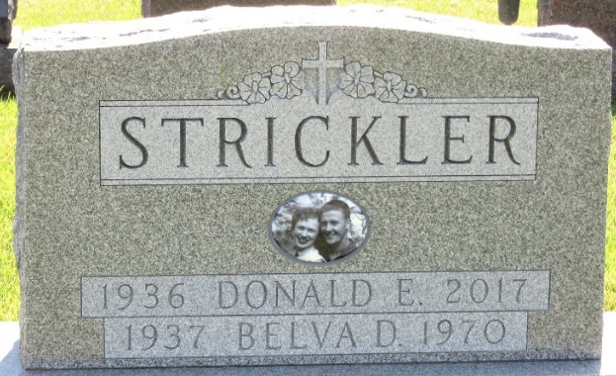
Photo by Barbara Baker Anderson

CRASH INJURIES CLAIM LIFE OF DECATUR WOMAN
DECATUR, Ind. – Mrs. Belva Strickler, 32, of Decatur, died at 9:50 p.m. Tuesday in Parkview Memorial Hospital in Fort Wayne from injuries sustained Saturday in an Erie-Lackawanna freight train-automobile collision in Decatur. She suffered a skull fracture and multiple rib fractures in the accident.
Mrs. Carol J. Frane, 35, of Decatur, also a passenger in the car, was reported in 'fair' condition at Parkview Hospital, where she is still in the intensive care unit.
Their husbands, Donald M. Frane, driver of the car, and Donald Strickler, 34, are both listed as in good condition in Adams County Memorial Hospital.
Mrs. Strickler's death was the 14th traffic fatality of the year in Adams County, and the fourth in Decatur.
The accident victim was born December 22, 1937 in Decatur, a daughter of Orland and Helen (May) Miller. She was married on August 6, 1955.
Mrs. Strickler, an office employee of Duo Marine, graduated from Decatur High School in 1955. She was a member of the First United Methodist Church and the Women of the Moose.
Surviving besides her husband, are a son, Michael Dean, at home; one daughter, Deborah Darlene, also at home; her father and stepmother, Orland and Franchon Miller of Decatur; four sisters, Mrs. Fred (Nira) Scheimann of Ottawa, Ill., Mrs. Jack (Sanda) Clem of Decatur, and Misses Vicky and Bobbie Miller, both of Decatur; a stepsister, Mrs. David (Jeannie) Miller of Spencerville, Ind.; two step brothers, Darrell Armstrong of Garrett, Ind., and Jerry Armstrong, of Decatur; and a grandmother, Mrs. Lewis (Pearl) Worthman, of Rt. 3, Decatur.
Her mother preceded her in death.
Funeral services will be at 2 p.m. Friday at the Zwick Funeral Home in Decatur, the Rev. Harold Leininger to officiate. Burial will be in Decatur Cemetery. Friends may call at the funeral home until the hour of services. The Women of the Moose will hold a memorial service at 7:30 p.m. today at the funeral home.

Van Wert Times Bulletin, Van Wert County, Ohio
Thursday, October 15, 1970

