Rosetta (Balsiger) Streit
1849 – November 10, 1924

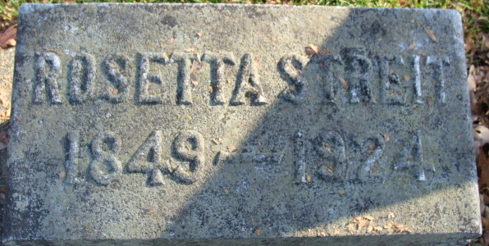
Photo by Alicia Kneuss

ROSAN STREIT DIES IN OHIO
Former Resident Of This City Dies; Burial In This City

The body of Mrs. Rosan Streit, age about 75, wife of the late Frederick Streit, formerly of this city, whose death occurred Monday, will be brought here from Dayton, Ohio, Thursday morning and burial will be in the Decatur Cemetery. Arthur Streit, a son of Mrs. Streit, was in the city yesterday making funeral arrangements.
Mrs. Streit while a resident of this city, was a member of the Reformed Church here and Mr. Streit at one time owned a five and ten cent store. Rev. C. W. Sauerwein of the Reformed Church at Berne will conduct the services at the grave.
Mr. and Mrs. Streit left Decatur about 1899 and moved to Dayton, at which place they have resided for the last 25 years.
Five children survive they being Arthur, Flora and Clara, of Dayton, and John and Alfred Streit of Oklahoma City, Okla. The husband died several years ago, and two daughters, Emma and Mary, died while the family lived in this city.
The trip from Dayton to Decatur will be made by auto and it is expected that the cortege will arrive here about 11:30 Thursday morning.

Decatur Daily Democrat; Adams County, Indiana
Wednesday, November 12, 1924
**
Web: Dayton, Ohio, U.S., Obituary Index, 1850-2013
Name Mrs. Rosetta Streit
Death Date Abt 1924
Publication Date 12 Nov 1924
Publication Place Dayton, Montgomery, Ohio, USA
Notes age 75; died Nov 10; buried in Decatur, IN
Publication Dayton Daily Journal
Citation pg. 5, col. 3

