Frederick Streit
June 13, 1839 – May 6, 1907

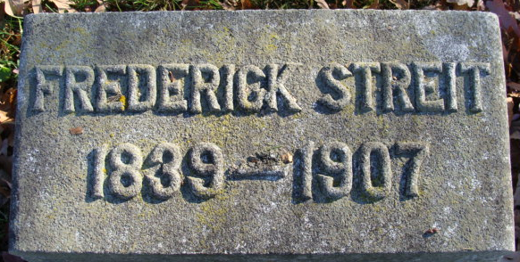
Photo by Alicia Kneuss

Mr. Henry (sic) I. Streit, a former resident of Montpelier, Ind., died last evening at his home, after an illness of two weeks caused by old age and other complications.
The remains will be brought to this city tomorrow and the funeral will be held Thursday morning at 10:30 o'clock. Interment will be made at the Decatur Cemetery.

Journal Gazette, Allen County, Indiana
May 8, 1907

**
Indiana, U.S., Death Certificates, 1899-2017
Name Frederick Streit
Gender Male
Race White
Marital Status Married
Age 67
Birth Date 13 Jun 1839
Birth Place Switzerland
Death Date 6 May 1907
Death Place Montpelier, Blackford, Indiana, USA
Death Registration Date 1907
Father Benedict Streit
Mother Stauffer
Informant Rosetta Streit; wife; Montpelier, Indiana
Burial May 9, 1907; Decatur, Indiana

