Clara Streit
1875 – July 4, 1946

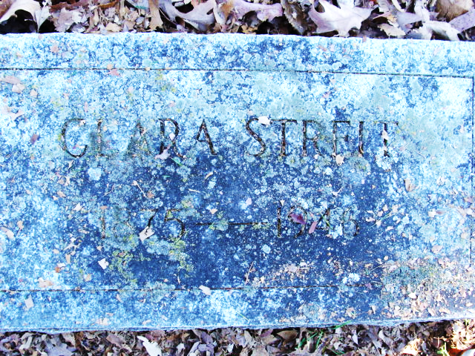
Photo by Alicia Kneuss

Miss Clara Streit Dies At Dayton, O.

Friends here received word of the death of Miss Clara Streit, formerly of this city, at Dayton, Ohio yesterday. Details were not obtainable. The body will be brought here for burial Saturday afternoon, arriving at the Decatur Cemetery at 1:30 o'clock.

Decatur Daily Democrat; Adams County, Indiana
Friday, July 5, 1946

**
Ohio, U.S., Death Records, 1908-1932, 1938-2022
Name Clara Streit
Death Date 4 Jul 1946
Death Place Dayton, Montgomery, Ohio, USA

