Arthur Edward Streit
July 28, 1880 – April 12, 1964

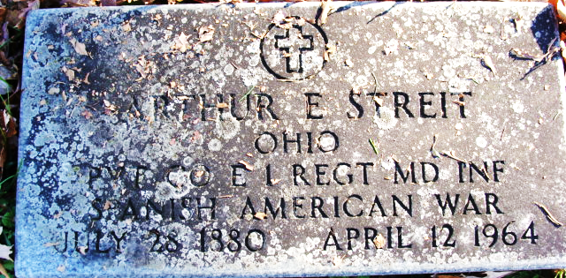
Photo by Alicia Kneuss

Arthur E Streit
in the U.S., Headstone Applications for Military Veterans, 1861-1985
Name Arthur E Streit
Rank Private
Birth Date 28 Jul 1880
Unit Co. E. 1st Regiment Md. Inf.
Enlistment Date 5 Jul 1898
Discharge Date 28 Feb 1899
Death Date 12 Apr 1964
Cemetery Decatur Cemetery
Cemetery Location Decatur, Indiana, USA
**
Arthur Edward Streit from tree Streit Family Tree
Birth 28 Jul 1880 Shelby, Richland, Ohio, USA
Residence 1930 Dayton, Montgomery, Ohio, USA
Death 12 Apr 1964 Dayton, Montgomery, Ohio, USA
Father Friedrich Streit (1849-1910)
Mother Rosina Balsiger (1848-1924)

