Maggie E. (Gilson) Strebe
October 20, 1867 – February 21, 1928

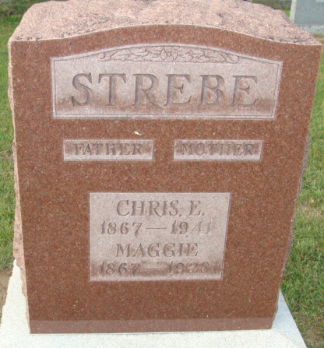
Photo by Alicia Kneuss

Maggie E. Strebe
in the Indiana, U.S., Death Certificates, 1899-2017
Name Maggie E. Strebe
[Maggie E. Gilson]
Gender Female
Race White
Marital Status Married
Age 60
Birth Date 20 Oct 1867
Birth Place Indiana
Death Date 21 Feb 1928
Death Place Fort Wayne, Allen, Indiana, USA
Death Registration Date 1928
Father James Gilson
Mother Adeline Fonner
Spouse Christ E. Strebe
Informant Christ E. Strebe
Burial February 25, 1925; Decatur, Indiana

