Christian E. “Christ” Strebe
August 1, 1867 – July 9, 1941

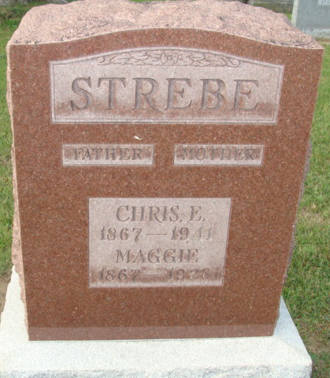
Photo by Alicia Kneuss

FORMER LOCAL RESIDENT DIES
Funeral Services For Christian Strebe To Be Held Saturday
Funeral services for Christian “Christ” Strebe, 73, former Decatur resident who died Wednesday at his home in Grand Rapids, Michigan, will be held Saturday afternoon at 2 o’clock at the Mungovan funeral home in Fort Wayne.
Death followed an illness of three months. He was born in ??. After residing here he moved to Fort Wayne, where he lived for many years before going to Michigan.
Surviving are the widow, ??, a daughter, Mrs. Martin Lose, of Fort Wayne, who is well known here, two brothers and three sisters.
The body may be viewed at the Mungovan funeral home and will be brought to Decatur for burial.
Adams County, Indiana Historical Museum
Scrapbook 1941B, image 61
Handwritten date: July 9, 1941
**
Michigan, U.S., Death Records, 1867-1952
Name: Christian Strebe
Gender: Male; Race: White
Marital status: Married
Death Age: 73
Birth Date: 1 Aug 1867; Birth Place: Auburn, Indiana
Death Date: 9 Jul 1941; Death Place: Grand Rapids, Kent, Michigan, USA
Father: Franklin Strebe; Mother: Julia Mansdofer
Spouse: Ruth; age 61
Informant: Mrs. Ruth Strebe; same address
Burial: July 12, 1941; Decatur, Indiana
File Number: 034636

