Lucinda A. (Heckey) Straw
June 15, 1880 – July 28, 1958

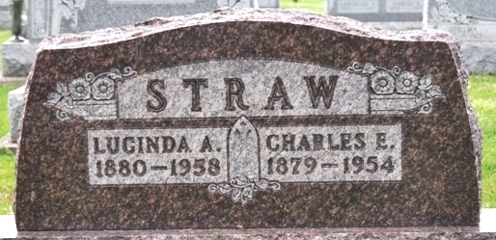
Photo by Alicia Kneuss

Anna Lucinda Straw
in the Indiana, U.S., Death Certificates, 1899-2017
Name Anna Lucinda Straw
[Anna Lucinda Heckey]
Gender Female
Race White
Marital Status Widowed
Age 78
Birth Date 15 Jun 1880
Birth Place Missouri
Death Date 28 Jul 1958
Death Place Fort Wayne, Allen, Indiana, USA
Death Registration Date 1958
Father William Heckey
Mother Lucinda
Informant Mrs. D. Dibble; daughter
Burial July 31, 1958; Decatur Cemetery; Decatur, Indiana

