Charles Edward Straw
March 8, 1879 – December 20, 1954

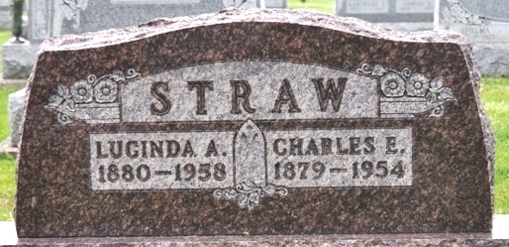
Photo by Alicia Kneuss

Charles Edward Straw
in the Indiana, U.S., Death Certificates, 1899-2017
Name Charles Edward Straw
Gender Male
Race White
Marital Status Married
Age 75
Birth Date 8 Mar 1879
Birth Place Indiana
Death Date 20 Dec 1954
Death Place Decatur, Adams, Indiana, USA
Death Registration Date 1954
Father Samuel Straw
Mother Unknown
Informant Mrs. Lucinda Straw; Decatur, Indiana
Burial December 23, 1954; Decatur Cemetery; Decatur, Indiana
**
Indiana, U.S., Marriage Certificates, 1960-2012
Name Charles Edward Straw
Gender Male
Race White
Marriage Age 59
Birth Date 8 Mar 1879
Birth Place Wells, Indiana
Marriage License Date 14 Apr 1938
Marriage Date 17 Apr 1938
Marriage Place Allen, Indiana, USA
Residence Place Grabill, Indiana
Father Samuel Straw
Mother Sarah Anna Arnold
Spouse Lucinda Ann Houser
Other Person Mabel Shinn
Officiator Kenneth Timmons

