Glenn A. Straub, Sr.
December 4, 1901 – March 15, 1988

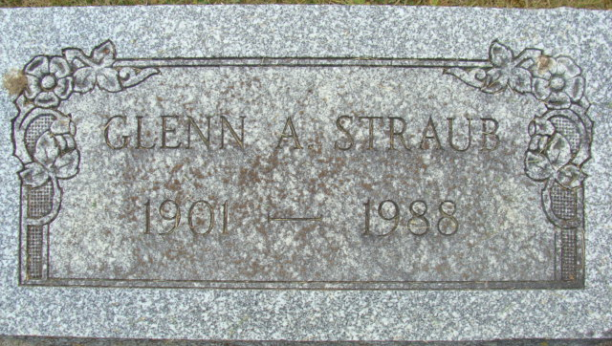
Photo by Alicia Kneuss

Glenn A Straub Sr
in the Indiana, U.S., Death Certificates, 1899-2017
Name Glenn A Straub Sr
Gender Male
Race White
Marital Status Widowed
Age 86
Birth Date 4 Dec 1901
Birth Place Adams County, Indiana
Death Date 15 Mar 1988
Death Place Ossian, Wells, Indiana, USA
Death Registration Date 1988
Father William A Straub
Mother Mellisa Steele
Informant Glenn A. Straub, Jr.; son; Decatur, Indiana
Burial March 18, 1988; Decatur Cemetery; Decatur, Indiana

