Fannie (Dreitzler) Straub
September 23, 1902 – July 15, 1949

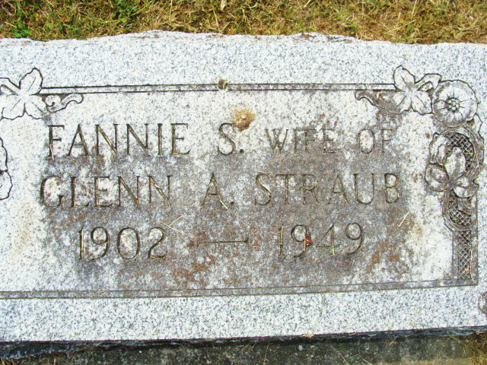
Photo by Alicia Kneuss

Fannie Straub
in the Indiana, U.S., Death Certificates, 1899-2017
Name Fannie Straub
[Fannie Dreitzler]
Gender Female
Race White
Marital Status Married
Age 46
Birth Date 23 Sep 1902
Birth Place Ohio
Death Date 15 Jul 1949
Death Place Allen, Indiana, USA
Death Registration Date 1949
Father Emmett Dreitzler
Mother Ella Case
Informant Hospital records
Burial July 17, 1949; Decatur Cemetery; Decatur, Indiana

