Esta (Gentis) Straub
April 23, 1882 – May 9, 1967

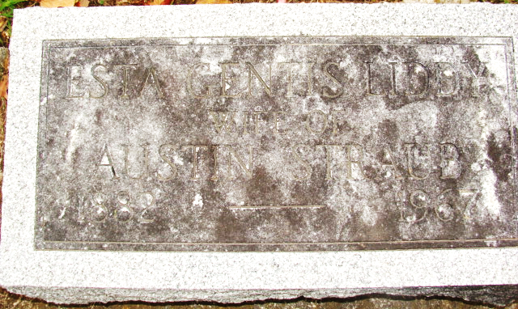
Photo by Alicia Kneuss

Esta Straub
in the Indiana, U.S., Death Certificates, 1899-2017
Name Esta Straub
[Esta Gentis]
Gender Female
Race Caucasian (White)
Marital Status Married
Age 85
Birth Date 23 Apr 1882
Birth Place Indiana
Death Date 9 May 1967
Death Place Bluffton, Wells, Indiana, USA
Death Registration Date 1967
Father George Gentis
Mother Anna Lehman
Informant Austin O Straub; husband; Decatur, Indiana
Burial May 11, 1967; Decatur Cemetery; Decatur, Indiana

