Lester L. Strahm
March 2, 1922 – July 29, 2003

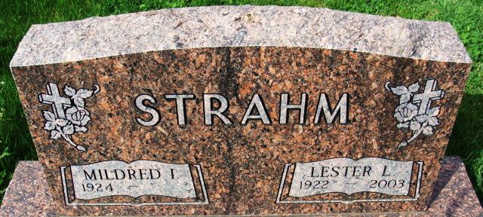
Photo by Alicia Kneuss
Lester L. Strahm, 81, of Decatur, died at home at 4:10 a.m. Tuesday.
He was born on March 2, 1922, in Adams County to Lewis and Sadie M. Biberstine Strahm and married Mildred I. "Millie" Marshall on February 27, 1943; she survives.
He retired on April 1, 1987 from the CTS Corp. plant in Berne as an engineering technician after a 21 year career. He was a member of Decatur Missionary Church, of which he was chairman of the board, a deacon, and a Sunday School teacher for many years.
He was a lifetime member of the Society of Manufacturing Engineers. During World War II, he served in the U. S. Army's medical corps from 1942-45 in Europe and was in the Battle of the Bulge.
Other survivors are three daughters, Sonja S. Strahm of Fort Wayne, Pamela L. Strahm of Indianapolis, and Mrs. Jim (Marlene) Gibson of Three Rivers, Michigan; one son, Richard L. Strahm of Fort Wayne; two sisters, Mrs. Kenneth (Jeannette) Yoder of Berne and Mrs. Robert (Florine) Edwards of Peoria, Illinois; two grandsons; and a great-grandson.
Three brothers are deceased, one dying in infancy.
Funeral services will be held at 10:30 a.m. Friday in Decatur Missionary Church, with burial in Decatur Cemetery, including military graveside rites by the color guard from American Legion Post 43 in Decatur.
Visiting hours are 2 to 5 and 6 to 8 p.m. Thursday in Zwick and Jahn Funeral Home, Decatur, and 9:30 to 10:30 a.m. Friday in the church.
Preferred memorials are to the church.

Decatur Daily Democrat, Adams County, Indiana
Wednesday, July 30, 2003

