Kenneth Dale Strahm
July 6, 1932 – July 27, 1997

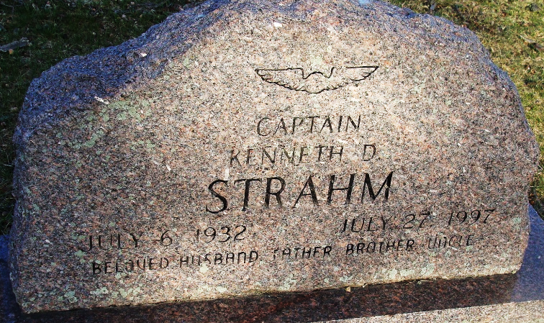
Photo by Alicia Kneuss
Kenneth Dale Strahm
in the Indiana, U.S., Birth Certificates, 1907-1944
Name Kenneth Dale Strahm
Gender Male
Birth Date 6 Jul 1932
Birth Place Decatur, Adams, Indiana, USA
Father William Strahm; age 34
Mother Laura May Poling; age 33; 3rd child, 2 living
Certificate Number 25951
Roll number 40474_356557
Volume Range 51 - 55

**
California, U.S., Death Index, 1940-1997
Name Kenneth Dale Strahm
Social Security # xxx
Gender Male
Birth Date 6 Jul 1932
Birth Place Indiana
Death Date 27 Jul 1997
Death Place Orange
Mother's Maiden Name Poling

