Jean E. (Oliver) Strahm-Hildebrand
September 24, 1923 – June 13, 2018

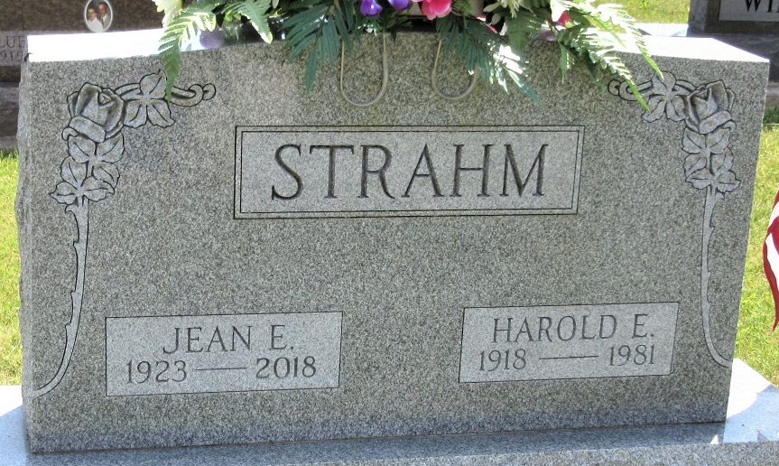
Photo by Alicia Kneuss
Jean E. Hildebrand
in the U.S., Cemetery and Funeral Home Collection, 1847-Current

Name Jean E. Hildebrand
[Jean E. Oliver]
Maiden Name Strahm
Gender Female
Death Age 94
Birth Date 24 Sep 1923
Birth Place Adams County, IN
Marriage Date 2 Aug 1986
Residence Place Decatur, IN
Death Date 13 Jun 2018
Burial Date 18 Jun 2018
Father Walter Oliver
Mother Pearl Oliver
Spouse Harold E. Strahm
Child Terry Strahm, Debra Harman, Donna Miesse
Siblings Franklin Oliver, Fredrick Oliver, Janice Hamrick,
Joan Workinger

**
Indiana, U.S., Marriage Certificates, 1960-2012
Name Carl Edward Hildebrand
Gender Male
Marriage Age 65
Birth Date abt 1921
Birth Place Indiana
Marriage Date 2 Aug 1986
Marriage Place Shelbyville, Shelby, Indiana, USA
Spouse Jean Strahon
Description Adam-Lake
Notes 2 N; Reference Number 1 Bx1448; Reference Number 2 Tr8552
Certificate Number 86-026107; Box Number 3h

