Harold E. Strahm
January 26, 1918 – October 27, 1981

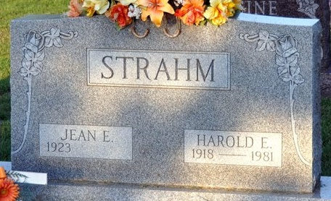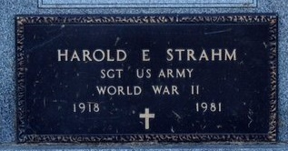
Photo by Deb Curry

Harold E. Strahm, 63, Rt. 8, Decatur, an employee of the Decatur General Electric Co., was dead on arrival at 1;55 p.m. Tuesday at the Adams Memorial Hospital. He was stricken with an apparent heart attack while at work at the local GE plant.
Mr. Strahm was a member of the Zion United Church of Christ and a trustee of the church. He was a veteran of World War II. Born on Jan. 26, 1918, in Adams County, he was the son of Philip and Lula K. Scherry-Strahm, and was married to Jean Oliver on Oct. 11, 1947; she survives.
Also surviving are one son, Terry E., Indianapolis; two daughters, Mrs. Malcolm (Donna) Miesse, and Mrs. Dan (Debra) Harman, both of Fort Wayne; three sisters, Mrs. Raymond (Martha) Kolter, Rt. 5, Decatur; Mrs. James E. (Selma O.) Myers, Decatur; Mrs. Harold (Dorothy) Scherry, Rt. 8, Decatur; and four grandchildren. One brother preceded him in death.
Funeral services will be held Friday at 10:30 a.m. at the Zion United Church of Christ, Rev. Lawrence E. Balleine officiating. Burial will be in the Decatur Cemetery. Friends may call at the Winteregg-Linn & Haggard Funeral Home after 2 p.m. Thursday.
Preferred memorials are to the church or the Adams County Heart Fund.
The body will lie in state at the church one hour prior to services.

Decatur Daily Democrat, Adams County, Indiana
Wednesday, October 28, 1981

