Marvin O. Stoutenberry
April 26, 1904 – October 15, 1988

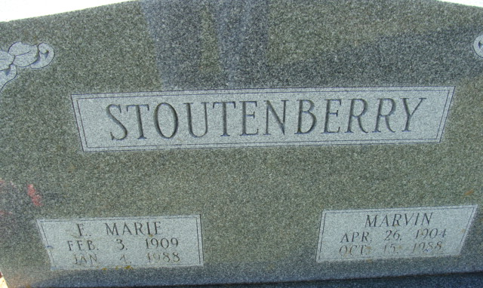
Photo by Alicia Kneuss

Marvin O Stoutenberry
in the Indiana, U.S., Death Certificates, 1899-2017
Name Marvin O Stoutenberry
Gender Male
Race White
Marital Status Widowed
Age 84
Birth Date 26 Apr 1904
Birth Place Adams County, Indiana
Death Date 15 Oct 1988
Death Place Decatur, Adams, Indiana, USA
Death Registration Date 1988
Father John D Stoutenberry
Mother Rosella Sautbine
Informant Patricia Barton; niece; North Webster, Indiana
Burial October 19, 1988; Decaur Cemetery; Decatur, Indiana

