Edna Marie (Kiggins) Stoutenberry
February 3, 1909 – January 4, 1988

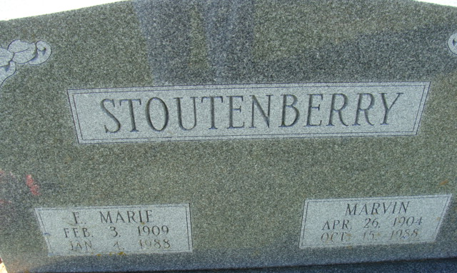
Photo by Alicia Kneuss

Marie Stoutenberry, 78, route 3, Bellmont Rd., Decatur, died at 7:07 p.m. Monday in Lutheran Hospital, Fort Wayne. She had been stricken with a stroke earlier in the day at Adams County Memorial Hospital.
She was a member of the Women of the Moose. Born on Feb. 3, 1909, in Van Wert County, O., she was the daughter of John F. and Lucy Boroff-Kiggins, and was married to Marvin Stoutenberry in 1926. They were married 61 years.
Surviving, in addition to the husband, is one sister, Mrs. Eltjo (Norma) Pool, Kalamazoo, Mich. Three sisters and two brothers preceded in death.
Services will be held at 1 p.m. Thursday at Zwick-Sefton & Jahn Funeral Home, Rev. Sylvester Martin officiating. Burial will be in Decatur Cemetery. Friends may call at the funeral home from 2-5 and 7-9 p.m. Wednesday.
Decatur Daily Democrat; Adams County, Indiana
Tuesday, January 5, 1988

