Matthew Darrell Stout
July 2, 1990 – July 2, 1990

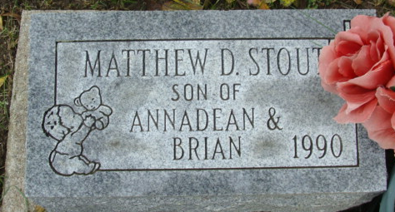
Photo by Alicia Kneuss

MATTHEW D. STOUT
Matthew Darrell Stout, son of Brian S. Stout and Annadean Gallant, both of Decatur, was stillborn at 7:29 a.m. Monday in Adams County Memorial Hospital.
The boy's father is employed at Gold Shield Fiberglass.
Also surviving are a step (cut off)

Decatur Daily Democrat, Adams County, Indiana
Tuesday, July 3, 1990

