Mary (Smalley) Stoops
May 10, 1811 – July 30, 1883

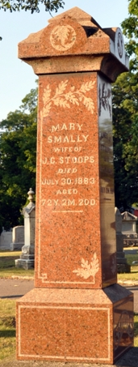
Photo by Deb Curry

Mary Smalley from tree Parker Family Tree
Birth 10 May 1811 Greene, Pennsylvania, USA
Marriage 24 Apr 1832 Greene, Pennsylvania, USA
Residence 1880 Decatur, Adams, Indiana, USA
Death 30 Jul 1883 Decatur, Adams, Indiana, USA
Father Jonas Smalley (1768-1836)
Mother Rebecca Dwire (Wise) (1769-1833)
Spouse James Carr Stoops (1807-1887)

