James Carr Stoops
August 7, 1807 – November 16, 1887

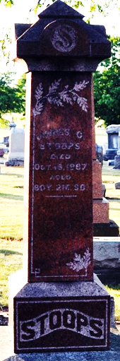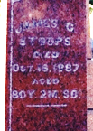
Photo by Deb Curry

James Carr Stoops from tree Parker Family Tree
Birth 7 Aug 1807 Green, Forest, Pennsylvania, USA
Marriage 24 Apr 1832 Greene, Pennsylvania, USA
Residence 1880 Decatur, Adams, Indiana, USA
Death 16 Nov 1887 Decatur, Adams, Indiana, USA
Father Eliakim Stoops (1762-1815)
Mother Margaret Carr (1761-1850)
Spouse Mary Smalley (1811-1883)

