Margaret (Shanklin) Stonestreet
May 5, 1913 – June 28, 1977

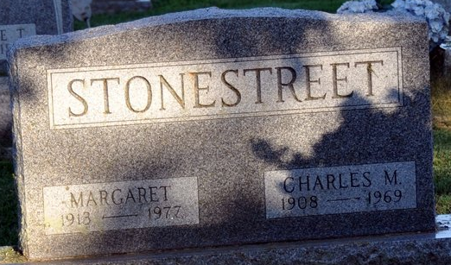
Photo by Deb Curry

MARGARET STONESTREET
Margaret Stonestreet, 64, of 620 Grant Street, widow of Charles M. Stonestreet, died at 3:25 p.m. Monday at the Adams County Memorial Hospital, where she had been hospitalized four days.
She was a member of the Starcher Baptist Church, North Charleston, West Virginia. Born in Smithers, West Virginia, on May 5, 1913, she was the daughter of Mont and Lelia Perry-Shanklin and was united in marriage on March 2, 1929 to Charles M. Stonestreet, who died December 31, 1969.
She lived in Decatur 14 years.
Survivors include four children, Charles H. Stonestreet, route 5, Anthony Wayne Meadows; Jack L. Stonestreet, Hurricane, West Virginia; Jack Trinosky, Van Wert, Ohio; Mrs. Cecil (Betty Richards, Oregon, Ohio; nine grandchildren and two great-grandchildren. One brother preceded her in death.
Funeral services will be conducted Wednesday at 2 p.m. and Winteregg-Linn & Haggard Funeral Home, with Rev. D. Charles Elson, officiating. Burial will be in the Decatur Cemetery. Friends may call at the funeral home after 2 p.m. today. The casket will be closed one hour prior to service time.

Decatur Daily Democrat, Adams County, Indiana
June 29, 1977

