Charles M. Stonestreet
September 30, 1908 – December 31, 1969

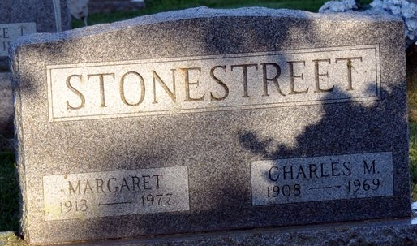
Photo by Deb Curry

Chas. Stonestreet is Taken by Death
Charles M. Stonestreet, 62, a retired mechanic, of 620 Grant Street, died at 3 p.m. Wednesday at the Adams County Memorial Hospital following an extended illness. He was born in Charleston, W. Va., Sept. 30, 1907, and was married to Mary Margaret Shanklin March 2, 1929. He had resided in Decatur for the past eight years.
Surviving is his wife; one daughter, Mrs. Cecil (Betty) Richards of Cleveland, O.; two sons, Charles H. Stonestreet of Decatur, and Jack L. Stonestreet of Charleston, W. Va.; three sisters, Mrs. Tom (Addie) McCoy of Orlando, Fla., and Mrs. Holly (Marie) Wood and Mrs. James O. (Pat) Perry, both of Charleston, W. Va.; and 10 grandchildren. Two brothers are deceased.
Services will be held at 2 p.m. Saturday at the Winteregg-Linn Funeral Home, with Rev. Wilmer Watson officiating. Burial will be in the Decatur Cemetery. Friends may call at the funeral home after 2 p.m. today until 1 p.m. Saturday, when the casket will be closed.
Decatur Daily Democrat, Adams County, Indiana
Fri. January 2, 1970

**
Indiana, U.S., Death Certificates, 1899-2017
Name Charles M Stonestreet
Gender Male; Race White
Marital Status Married
Age 61
Birth Date 30 Sep 1908
Birth Place West Virginia
Death Date 31 Dec 1969
Death Place Decatur, Adams, Indiana, USA
Parents Unknown
Spouse Mary Margaret Shanklin
Informant Mary Margaret Stonestreet; wife; Decatur, Indiana
Burial January 3, 1970; Decatur Cemetery; Decatur, Indiana

