Rachel Ann (Johnson) Stoneburner
March 28, 1859 – February 25, 1920

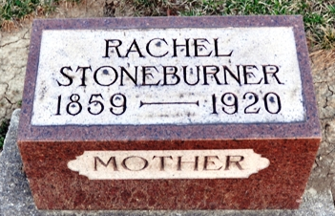
Photo by Deb Curry

SUFFERING ENDS
Mrs. Rachael Stoneburner Died this Morning at Home of Daughter
CANCER WAS CAUSE - Was Born in Adams County and was 61 Years of Age - Here Two Weeks

Following several years of suffering from cancer, Mrs. Rachael Stoneburner passed away this morning at 9:15 at the home of her daughter, Mrs. Adam Schafer. She had only been seriously ill for the past ten days. She had been making her home with her daughter, Mrs. Bertha Rackstraw of Fort Wayne and came to the home of her other daughter, Mrs. Schafer, only two weeks ago.
She was born in Adams County and was 61 years of age when she passed away. She spent her entire life near and in Decatur. In early womanhood she was united in marriage to Abraham Stoneburner, who still survives, besides four children: Mrs. Bertha Rackstraw of Fort Wayne, Tom Stoneburner of Kendallville and Mrs. Adam Schafer and I. B. Stoneburner, of this city.
Three sisters, Mrs. Chaney of Plymouth, Ind., Mrs. George Crist, of Kirkland Township and Miss Mayme Johnson, of this city, and three brothers, Jacob Johnson of Washington Township, B. B. Johnson of Centerville, Kansas and A. S. Johnson, Kansas City.
Mrs. Stoneburner was a faithful member of the M. E. Church and her death takes a kind mother and loving friend from her home and friends.

Decatur Daily Democrat, Adams County, Indiana
Wednesday, February 25, 1920

**
Indiana, Death Certificates, 1899-2011

Name: Ratchel Ann Stonetrmer
[Rachel Ann Stoneburner]
[Ratchel Ann Johnson]
Gender: Female
Race: White
Age: 60
Birth Date: 28 Mar 1859
Birth Place: Adams A Ind.
Death Date: 25 Feb 1920
Death Place: Decatur, Adams, Indiana, USA
Father: Thomas Johnson
Mother: Eliza Ball
Informant: Mrs. Adam Shaff; Decatur, Indiana
Burial: February 27, 1920; Decatur Cemetery

