Mary Elizabeth (Barnett) Stoneburner
March 30, 1870 – March 20, 1971

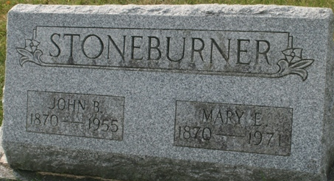
Photo by Jacquie Eisenhut

Mrs. Stoneburner Services Tuesday
Funeral services for Mrs. Mary "Manie" Stoneburner, 100, who died Saturday morning at the Lakeview Nursing Home, will be conducted at 2 p.m. Tuesday at the Zwick Funeral Home, with Rev. Donald Wilks officiating. Friends may call at the funeral home until time of the services. Eastern Star memorial services will be conducted at 7:30 p.m. today. Burial will be in the Decatur Cemetery.
Preferred memorials are to the Monroe Methodist Church.
**
MARY STONEBURNER
DECATUR, Ind. – Mrs. Mary (Manie) Stoneburner, 100, died at 9:15 a.m. Saturday at the Lakeview Nursing Home in Decatur. Born March 30, 1870, she was the daughter of James and Lydia Barnett of Adams County.
Mrs. Stoneburner and her late husband, John E., started the first motion picture theatre in Decatur and the second one in the state of Indiana.
There are no immediate survivors.
Funeral services will be at 2 p.m. Tuesday at the Zwick Funeral Home in Decatur, the Rev. Donald E. Wilks to officiate. Burial will be in Decatur Cemetery.

Van Wert Times Bulletin, Van Wert County, Ohio
March 22, 1971
**
MANIE STONEBURNER
Mary Elizabeth Stoneburner, called Mannie by family and friends, lived over a full century of life. She was one of ten children of James and Lydia Andrews Barnett, born on March 30, 1870, and was the last survivor of her family at her death on March 20, 1971.
Her father, James Barnett, came to Adams County in 1849, settling on a farm near Elmtree Crossroads in Washington Township. He was well-known in the county as a schoolteacher. She often related the story of how her father blazed the trees through the woods to the log school so that the children would not get lost in the dense forest. She told how the entire area was thick with trees, and her father used an ax to clear the ground for farming. He also employed the use of a team of oxen to plow. The family lived in the log house which her father built.
Mary Elizabeth Barnett was married to John Stoneburner on April 17, 1890. During their early married life, the couple ventured to Wyoming and Kansas to work in the oil fields. The train only went so far and they had to walk into the area of the oil fields.
John Stoneburner opened the first movie theatre in Decatur in 1906, in a 20 by 40 foot room south of the courthouse. He also sold musical instruments. During his life he also served as Washington Township trustee.
John and Manie were the parents of only one child, Louva, who married Rollin Waltz. She had no children so there are no descendants to carry on the heritage of this pioneer couple.
1979 History of Adams County, Indiana; Vol. I, editor Dick D. Heller, Jr., 1980

