John B. Stoneburner
March 20, 1870 – December 29, 1955

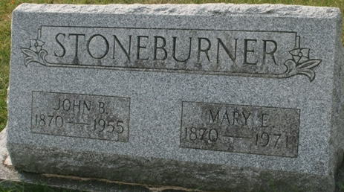
Photo by Jacquie Eisenhut

John B. Stoneburner Dies Thursday Night
City's First Movie Proprietor is Dead
John B. Stoneburner, 85, retired farmer, owner of Decatur's first moving picture theater, and former Washington Township trustee, died at 11:15 o'clock Thursday night at the Adams County Memorial Hospital. He had been in failing health for the past four years.
Mr. Stoneburner opened this city's first motion picture theater in 1905, in fact one of the first such houses of entertainment in the country and operated a theater here for a number of years. He served two terms as Washington Township trustee from 1943 to 1951.
Born in Washington Township March 20, 1870, he was a son of Israel and Catherine Weldy-Stoneburner. He was married to Mary E. Barnett on April 17, 1890. Mr. and Mrs. Stoneburner resided on a farm two miles west and one mile north of Monroe.
Mr. Stoneburner was a member of the Monroe Methodist Church, was a 50-year member of the Masonic Lodge and a member of the Order of Eastern Star.
His wife is the only near survivor. One daughter, Mrs. Louva Waltz, died in 1942, and four sisters and four brothers also proceeded him in death.
The body was removed to the Zwick Funeral Home, where friends may call after 7 o'clock this evening until 1 p.m. Sunday after which it will lie in state at the Monroe Methodist Church. Funeral services will be held at 2:30 p.m. Sunday at the church, the Rev. Ralph Johnson officiating. Burial will be in the Decatur Cemetery.

Decatur Daily Democrat, Adams County, Indiana
December 30, 1955

**
Indiana, U.S., Death Certificates, 1899-2017
Name John B Stoneburner
Gender Male
Race White
Marital Status Married
Age 85
Birth Date 20 Mar 1870
Birth Place Indiana
Death Date 29 Dec 1955
Death Place Rural, Adams, Indiana, USA
Death Registration Date 1955
Father Israel Stoneburner
Mother Catharine Weldy
Informant Mrs. John Stoneburner; Decatur, Indiana
Burial January 1, 1956; Decatur Cemetery; Decatur, Indiana

