James H. Stone
January 12, 1836 – October 3, 1916

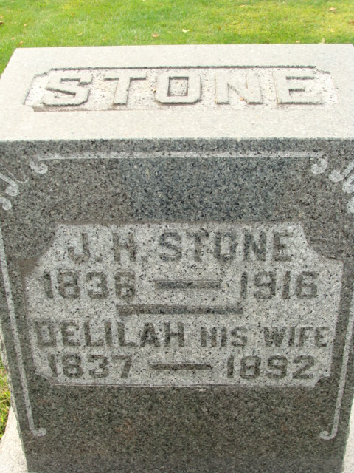
Photo by Alicia Kneuss

James H Stone
in the Indiana, U.S., Death Certificates, 1899-2017
Name James H Stone
Gender Male
Race White
Marital Status Widower
Age 80
Birth Date 12 Jan 1836
Birth Place Ohio
Death Date 3 Oct 1916
Death Place Decatur, Adams, Indiana, USA
Death Registration Date 1916
Father Horace Stone
Mother Delilah Weldy [sic - spouse]
Informant Victoria Stone; Decatur, Indiana
Burial October 6, 1916; Decatur Cemetery

**
James Horace Stone from tree Hamman/Baith/Bradford Family Tree
Birth 12 Jan 1836 Logan, Hocking, Ohio, USA
Marriage 25 Sep 1893 Indiana, USA
Residence 1910 Decatur, Adams, Indiana, USA
Death 3 Oct 1916 Decatur, Adams, Indiana, USA
Father Horace Stone (1798-1876)
Mother Elizabeth Betsey Ramsey (1794-1870)
Spouse Delilah Weldy (1837-1892)

