Delilah (Weldy) Stone
May 14, 1837 – April 8, 1892

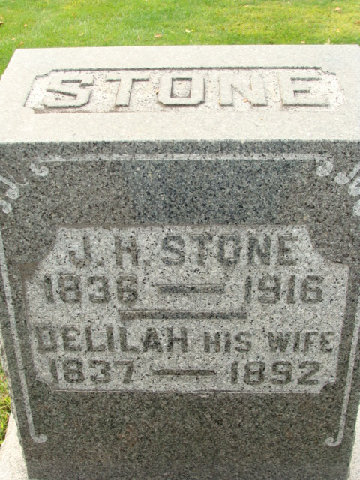
Photo by Alicia Kneuss

Delilah Weldy from tree Hamman/Baith/Bradford Family Tree
Birth 14 May 1837 Bremen, Fairfield, Ohio, USA
Marriage 10 May 1860 Logan, Hocking, Ohio, USA
Residence 1880 Decatur, Adams, Indiana, USA
Death 8 April OR 12 Oct 1892 Decatur, Adams, Indiana, USA
Father Peter Weldy (1796-1868)
Mother Susannah Huddle (1799-1837)
Spouse James Horace Stone (1836-1916)

