James Stogdill
December 14, 1873 – March 5, 1965

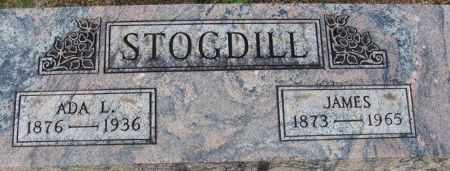
Photo by Alicia Kneuss

James Stogdill
in the Indiana, U.S., Death Certificates, 1899-2017
Name James Stogdill
Gender Male
Race White
Marital Status Widowed
Age 91
Birth Date 14 Dec 1873
Birth Place Union Twp Andms Co Indiana
Death Date 5 Mar 1965
Death Place Vincennes, Knox, Indiana, USA
Death Registration Date 1965
Father William Stogdill
Mother Amelia Martin
Informant Rev. Dennis Barber; friend; Bicknell, Indiana
Burial March 8, 1965; Maplewood Cemetery; Decatur, Indiana

