Ada L. (Blossom) Stogdill
February 13, 1876 – September 2, 1936

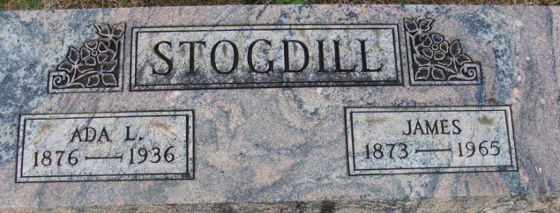
Photo by Alicia Kneuss

Indiana, Death Certificates, 1899-2011
Name: Ada Stogdill
[Ada Blossom]
Gender: Female
Race: White
Age: 60
Marital status: Married
Birth Date: 13 Feb 1876
Birth Place: Indiana
Death Date: 2 Sep 1936
Death Place: Ft Wayne, Allen, Indiana, USA
Father: Lyman Blossom b. OH
Mother: unnamed Sheets b. IN
Spouse: James Stogdill
Burial: Maplewood Cem. Sept 4, 1936

