Margarete M. (Deden) Stockman
June 3, 1929 – September 11, 2020

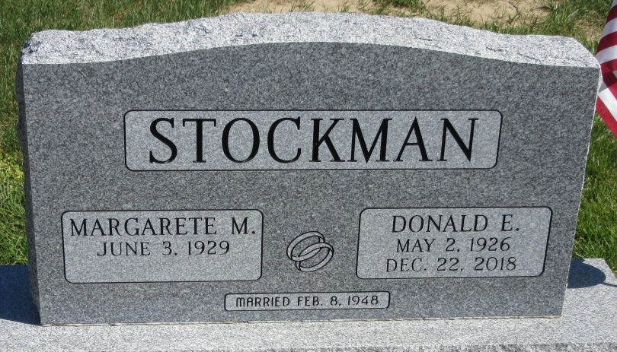
Photo of PLS
Margarete M. Stockman 91, of Decatur, IN, passed away Friday, September 11, 2020 at Millers Merry Manor in Fort Wayne. She was born into the home of the late Hubert and Frieda (Roth) Deden, first generation German immigrants on June 3, 1929 in Plymouth, IN. On February 8, 1948 Margarete married Donald E. Stockman and after 70 years together he preceded her in death on December 22, 2018.
She was a former member of Zion Lutheran Church and worked as a homemaker.
She is survived by her son, D. Eric (Cheryl) Stockman of Decatur, IN; her daughter, Ramona L. Dickey of Decatur, IN; 2 grandchildren.
A Funeral Service will be held on Tuesday September 15, 2020 at 1:00 p.m. at Haggard-Sefton- Hirschy & Zelt Funeral Home, with visitation 1 hour prior from 12:00 - 1:00 p.m. Pastor Dan York will be officiating and burial will immediately follow in the Decatur Cemetery.
Memorials may be given to the A.C.C.F. Angel Alzheimer’s Fund.

Haggard & Sefton Funeral Home, Adams County, Indiana
September 12, 2020

