Donald Earl Stockman
May 2, 1926 – December 22, 2018

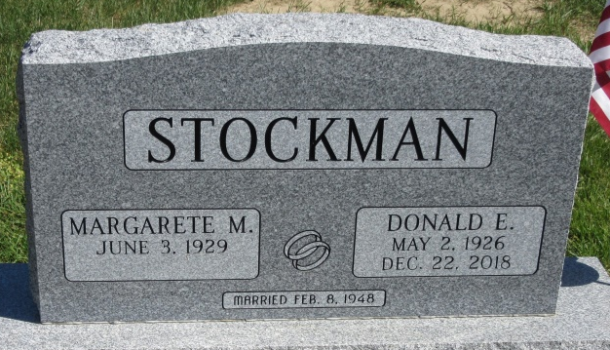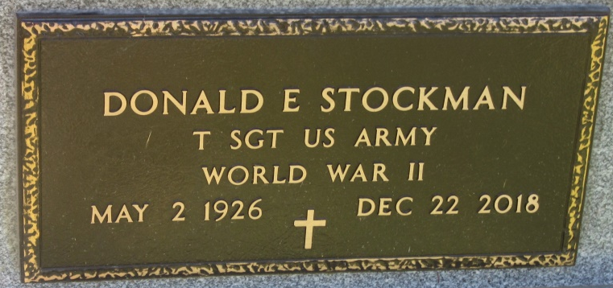
Photo of PLS
Donald E. Stockman, 92, of Decatur, Indiana passed away on Saturday, December 22, 2018 at Miller’s Merry Manor in Ft. Wayne, IN. He was born on May 2, 1926 in Marshall County, Indiana to Timothy and Helen (Reed) Stockman. On February 8, 1948 he married Margarete Deden.
He served in the U.S. Army during WW II, stationed in Occupied Japan as a Tech Sergeant. Don was Owner/Operator of Stockman Farm Service and retired in 1988 after 25 years. He was baptized in and a former member of Zion Lutheran Church and an active member of the American Legion Post #43.
Don is survived by his wife of 70 years, Margarete; 1 son, Eric (Cheryl) Stockman; 1 daughter, Ramona Dickey, and 2 granddaughters, Christina Stockman and Samantha Stockman, all of Decatur, IN. He was preceded in death by brother, Billy Dale Stockman who died at birth in 1920.
A Visitation will be held on Thursday, December 27, 2018 from 4:00 – 8:00 p.m. at Haggard-Sefton-Hirschy & Zelt Funeral Home.
The Funeral Service will be held at 11:00 a.m. on Friday, December 28, 2018 also at Haggard-Sefton-Hirschy & Zelt Funeral Home. Burial will take place at the Decatur Cemetery with Graveside Rites by the American Legion Post #43 Color Guard.

Haggard & Sefton Funeral Home, Adams County, Indiana
December 23, 2018

