Ray Stingely, D.D.S.
September 30, 1902 – April 6, 1970

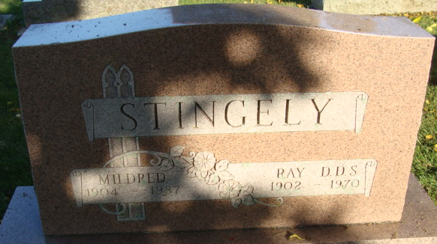
Photo by Alicia Kneuss

Dr. Ray Stingley Dies Unexpectedly

Dr. Ray Stingley, 67, a Decatur dentist for more than 30 years, died suddenly of a heart attack at 8:15 p.m. Monday at his home, 952 Mercer Avenue. Dr. Stingley had been in his office as usual Monday.
A native of Fulton County, he was born there Sept. 30, 1902, to Jacob and Sadie Bish-Stingley. He was married to Miss Mildred M. Bond Aug. 27, 1927.
Dr. Stingley began the practice of dentistry in Geneva in 1931, and moved his office to Decatur, in the K. of C. building in 1937.
The well-known dentist was a member of St. Mark's United Methodist Church. He was a past master of Decatur Lodge 571, F & M, the Fort Wayne Scottish Rite, Order of Eastern Star, the Rotary Club, American Dental Association, and the Isaac Knapp district Dental Society.
Surviving in addition to his wife is one son, Major Norman E. Stingley, stationed at Vandenburg Air Force Base in California; one sister, Mrs. Fred (Gertie) Mills of Rochester, and one grandchild. One sister and three brothers are deceased.
Funeral services will be conducted at 2 p.m. Thursday at the Winteregg-Linn Funeral Home with Rev. Fuhrman P. Miller and Rev. Donald Kime officiating. Burial will be in the Decatur Cemetery. Friends may call at the funeral home after 2 p.m.

Decatur Daily Democrat, Adams County, Indiana
Tuesday, April 7, 1970

