Judy E. (Arner) Stewart
September 2, 1950 -

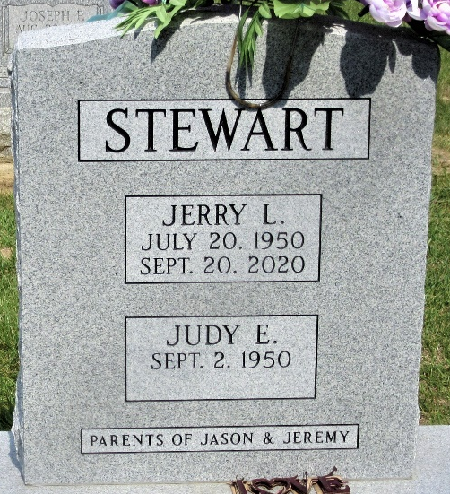
Photo by PLS

