Jerry Lee Stewart
July 20, 1950 – September 20, 2020

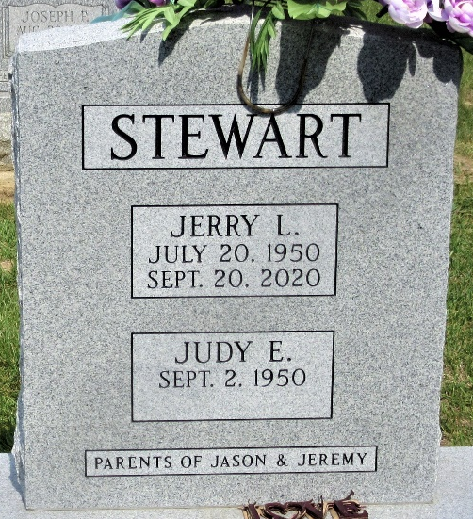
Photo by PLS

Jerry L. Stewart, 70, of Decatur, IN passed away on Sunday, September 20, 2020 at his residence. Jerry was born on July 20, 1950 in Union City, IN to the late Alva O. and Gladys I. (Davis) Stewart. On January 10, 1970, he married Judy E. Arner.
Jerry had worked for Decatur Casting before retiring.
He is survived by his wife of 50 years, Judy E. Stewart of Decatur; 2 sons, Jeremy (Dusty) Stewart of Monroeville and Jason Stewart of Decatur; a brother, Everett (Regina) Stewart of Ridgeville, IN; 2 grandchildren, Samantha Stewart; Reece Stewart and a step grandchild, Eevie. Jerry was preceded in death by 2 brothers, Gene and Kenny Stewart; a sister, Doris Star; 2 sisters-in-law, Bobbi Stewart and Erna “Chick” Stewart.
Visitation will be from 5:00-7:00 p.m. on Wednesday, September 23, 2020 at Haggard-Sefton-Hirschy & Zelt Funeral Home. Funeral Service will be held at 10:00 a.m. on Thursday, September 24, 2020 also at the funeral home with 1 hour calling prior to service from 9:00-10:00 a.m. Pastor Rick Stewart will be officiating. Burial will be in Decatur Cemetery.

Haggard & Sefton Funeral Home, Adams County, Indiana
September 21, 2020

