Charles McCoy Stewart
October 15, 1812 – October 26, 1883

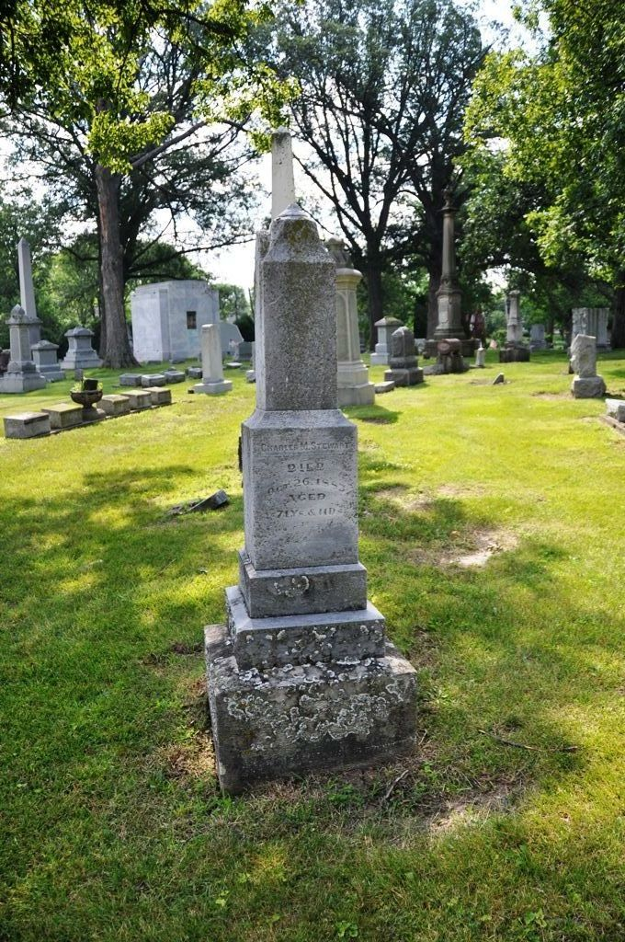
Photo by Deb Curry

Charles McCoy Stewart from tree Coffing Family Tree
Birth 15 Oct 1812 Tyler, West Virginia, USA
Residence 1880 Decatur, Adams, Indiana, USA
Death 26 Oct 1883 Decatur, Adams, Indiana, USA
Spouse Judith Niblick (1814-1889)

