Winifred (Russell) Stevens
October 23, 1883 – March 29, 1948

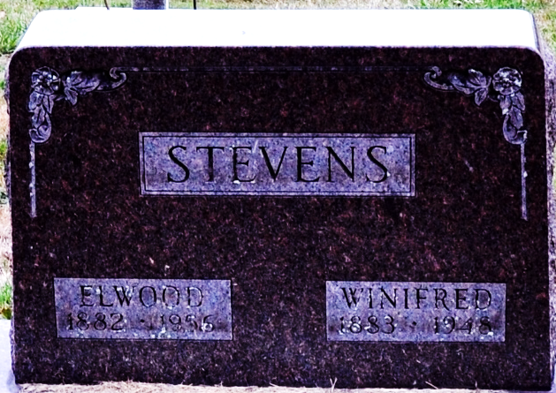
Photo by Deb Curry

Winifred Stevens
in the Michigan, U.S., Death Records, 1867-1952
Name Winifred Stevens
[Winifred Russell]
Gender Female
Race White
Marital Status Married
Death Age 64
Birth Date 23 Oct 1883
Birth Place Decatur, Ind
Death Date 29 Mar 1948
Death Place Fawn River, St Joseph, Michigan, USA
Father William Russell
Mother Winifred Russell
File Number 006596
**
Indiana, U.S., Marriages, 1810-2001
Name Winifred Russell
Gender Female
Race White
Event Type Marriage Registration (Marriage)
Birth Place Indiana
Marriage Date 5 Oct 1902
Marriage Place Decatur, Indiana, United States
Residence Place Decatur
Father William Russell
Mother Winifred Smith
Spouse Elwood Stevens
Page 131

