William Harvey Stevens
July 30, 1888 – March 10, 1955

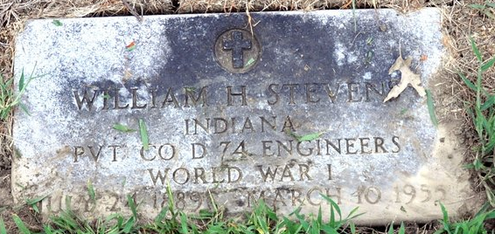
Photo by Deb Curry

William Harvey Stevens
in the Indiana, U.S., Death Certificates, 1899-2017
Name William Harvey Stevens
Gender Male
Race White
Marital Status Never Married (Single)
Age 66
Veteran World War I
Birth Date 30 Jul 1888
Birth Place Decatur, Indiana
Death Date 10 Mar 1955
Death Place Rural, Tippecanoe, Indiana, USA
Death Registration Date 1955
Father Aaron Stevens
Mother Jennie Summers
Informant Hospital records; Soldiers' Home
Burial March 12, 1955; Decatur Cemetery; Decatur, Indiana

