Wayne A. Stevens
May 24, 1922 – June 27, 2003

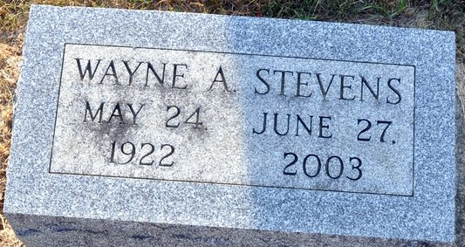
Photo by Deb Curry

Wayne A. Stevens, 81, of Fort Wayne, died Friday, June 27, 2003, at Hospice Home of Northeast Indiana. Born May 24, 1922, in Van Wert County, Ohio, he was the son of Richard and Elizabeth (Harker) Stevens.
He was a Teamster Truck Driver for 42 years, retiring in 1985.
Surviving is his daughter, Rhonda Riley of Fort Wayne; a sister, La Trebea Pierce of Monroeville; three grandchildren, Diana Leslie, Shenna Ballard and Nathaniel Ballard, all of Fort Wayne.
Graveside service is 10 a.m. Tuesday at Decatur Cemetery.
Memorials to Hospice Home of Northeast Indiana.

News-Sentinel, Allen County, Indiana
Sunday, June 29, 2003

**
Indiana, U.S., Death Certificates, 1899-2017
Name Wayne A Stevens
Gender Male
Race White
Marital Status Divorced
Age 81
Birth Date 24 May 1922
Birth Place Van Wert County, Ohio
Death Date 27 Jun 2003
Death Place Fort Wayne, Allen, Indiana, USA
Death Registration Date 2003
Father Richard Stevens
Mother Elizabeth Harker
Informant Mrs. Rhonda (Stevens) Riley; daughter; Fort Wayne, Indiana
Burial July 1, 2003; Decatur Cemetery; Decatur, Indiana

