Velma K. (Kelley) Stevens
May 11, 1916 – April 25, 2006

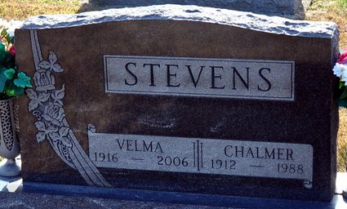
Photo by Deb Curry

Velma K. Stevens, 89 of rural Decatur passed away Tuesday, April 25, 2006 at her residence. She was born on May 11, 1916 to William and Sylvia (Beltz) Kelley. She married Chalmer J. Stevens on August 19, 1935, he passed away on June 14, 1988.
She was the mother of 3 children - 1 son Larry L. Stevens of Decatur, 2 daughters Mrs. David (Beverly A.) Beatty of Ft. Wayne & Mrs. Thomas (Kay E.) Foy of Venice, FL; 2 sisters Luella Butler and Mrs. Ralph (Barbara) Busse both of Decatur; 4 grandchildren and 4 great grandchildren. Preceded her in death are her parents, husband, 2 brothers and 2 sisters.
Velma was a homemaker and a member of the Union Chapel United Methodist Church and it's Faith Circle and United Methodist Women.
Visitation will be from 4-8 pm Friday, April 28, 2006 at Haggard & Sefton Funeral Home and the funeral will be Saturday at 2:00 pm also at the funeral home. Rev. Ed Kargas will be officiating and burial is in Decatur Cemetery.
Memorials are to Union Chapel United Methodist Church.

Haggard & Sefton Funeral Home, Adams County, Indiana
April 26, 2006

