Russell Stevens
April 1, 1903 – January 11, 1905

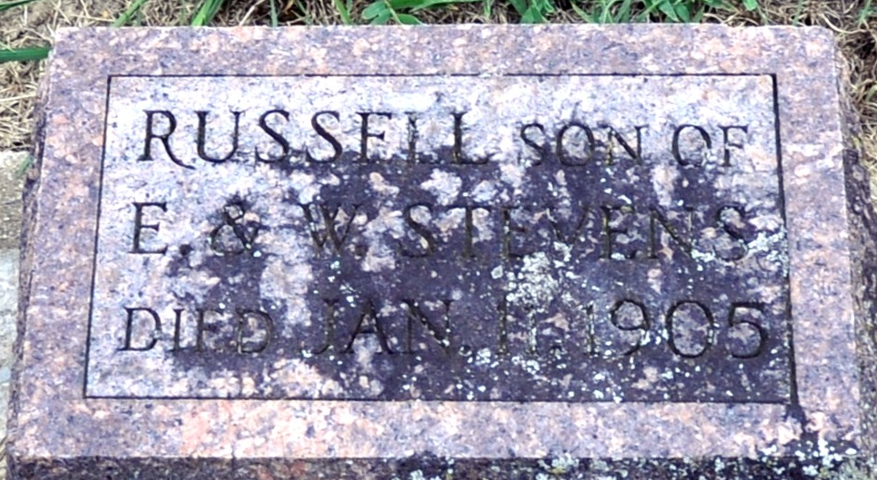
Photo by Deb Curry

Russell Stephens
in the Indiana, U.S., Death Certificates, 1899-2017
Name Russell Stephens
Gender Male
Race White
Marital Status Single
Age 1 year, 9 months, 10 days
Birth Date 1 Apr 1903
Birth Place Decatur, Indiana
Death Date 11 Jan 1905
Death Place Decatur, Adams, Indiana, USA
Death Registration Date 1905
Father Elwood Stephens
Mother Winifred Russell
Informant Elwood Stephens; Decatur, Indiana
Burial January 13, 1905; Maplewood Cemetery

