Roger Lee Stevens
August 18, 1932 – November 25, 2016

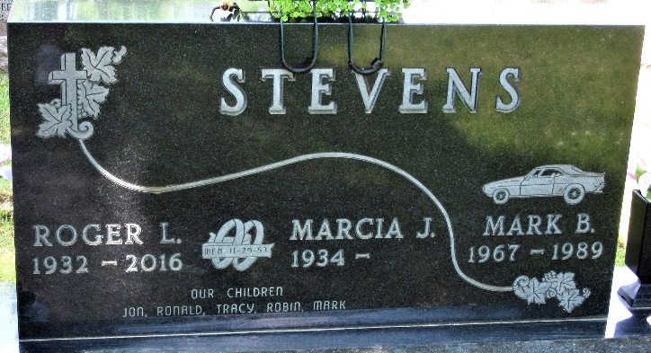
Photo by PLS

Roger L. Stevens, 84, of Decatur, Indiana, passed away on Friday, November 25, 2016 at Ossian Health and Rehabilitation. He was born on August 18, 1932, in Wren, Ohio to the late Ralph R. and Mildred I. (Frisinger) Stevens. On November 29, 1953, Roger married Marcia J. Becker.
He was a member of St. Mark’s United Methodist Church, where he served on many different committees. He loved playing the drums at church for the contemporary service and also at the park in Sebring, Florida.
He served his country in the U.S. Navy during the Korean War. He was also the “Honor Man” for Navy Boot Camp 128 Company.
Roger worked as a salesman for Toro Distributors out of Indianapolis and Ft. Wayne and was also employed by Central Soya for 14 years. He was also a member of the Elks Lodge B.P.O.E. 993, where he served as Past Exalted Ruler from 1978-1979 and 1980-1981. Roger also enjoyed golf, bowling, baseball, and fast pitch softball.
He is survived by his wife of 63 years, Marcia J. Stevens of Decatur; 3 sons, Jon C. (Lou Anne) Stevens of Decatur, Ronald J. (Stephanie) Stevens of Ft. Wayne, Tracy L. (Deb) Stevens of Decatur; a daughter, Mrs. Keith (Robin) Gerber of Decatur; 9 grandchildren, Mandy (Chad) Poling, Sarah (Chad) Johnson, Jon A. (Tracy) Stevens, Josh (Christy) Stevens, Kyle (Cari) Stevens, Elliot Stevens, Abby (Johnny) Tippmann, Rachel Gerber, and Hope Gerber, 15 great grandchildren, and a great-great grandchild.
Roger was preceded in death by his son, Mark B. Stevens on November 13, 1989.
Visitation will be from 3:00 - 7:00 p.m. on Wednesday, November 30, 2016 at Haggard-Sefton & Hirschy Funeral Home, with an Elks Memorial Service at 7:00 p.m. Funeral Service will be held at 1:00 p.m. on Thursday, December 1, 2016 at St. Mark’s United Methodist Church, with visitation 1 hour prior to the service from 12:00 - 1:00 p.m. Pastor Chris Gadlage will be officiating. Burial will take place in the Decatur Cemetery with Military Graveside Rites by the American Legion Post 43 Color Guard.
Memorials are to St. Mark’s United Methodist Church Music Department or the A.C.C.F. Mark Stevens Baseball Scholarship Fund.
Haggard & Sefton Funeral Home, Adams County, Indiana
November 26, 2016

**
Indiana, U.S., Death Certificates, 1899-2017
Name Roger L Stevens
Gender Male
Race White
Age 84
Birth Date 18 Aug 1932
Birth Place Wren, Ohio
Death Date 25 Nov 2016
Death Place Ossian, Wells, Indiana, USA
Death Registration Date 2016
Father Ralph R Stevens
Mother Mildred Frisinger
Spouse Marcia J Becker
Informant Marcia Stevens; spouse; Decatur, Indiana
Burial Decatur Cemetery; Decatur, Indiana
Certificate Number 056211

