Roger A. Stevens, Sr.
July 9, 1942 – June 15, 2012

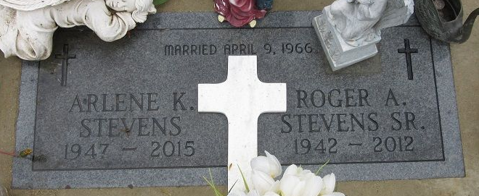
Photo by PLS

Roger A. Stevens, Sr., 69 years old of Decatur, Indiana, passed away on Friday, June 15, 2012 at Canterbury Nursing & Rehabilitation located in Fort Wayne.
He was born on Thursday, July 9, 1942 in Adams County, Indiana the son of the late Lloyd E. Stevens and the late Serena E. (Evans) Stevens. He married Arlene K. Stetler on April 9, 1966.
Roger retired from Decatur Casting with thirty years of service.
Surviving are his wife, Arlene K. Stevens of Decatur; daughter, Pamela S. (Jim) McCullough of Decatur; daughter, April A. (Gary Lautzenheiser) Stevens of Muncie; son, LaVerne D. (Jonetta) Stevens of Portland; son, Roger A. (Ellen) Stevens, Jr. of Decatur; son, David A. Stevens of Decatur; daughter, Debra (Albert) Bowen of Lima, Ohio; son, Thomas R. (Stephanie) Johnson of Lima, Ohio; seventeen grandchildren; and sixteen geat-grandchildren.
Preceding Roger in death were four brothers; Lloyd, Chester, Richard & Raymond Stevens and one sister; Goldie Mae Need.
Funeral services will be held at 7:00 p.m. Tuesday, June 19, 2012 in the Zwick & Jahn Funeral Home. Burial will be in Decatur Cemetery.
Friends will be received from 4 to 7 p.m., Tuesday, June 19 in the Zwick & Jahn Funeral Home, Decatur.
Preferred memorials are to the family.

Zwick & Jahn Funeral Home, Adams County, Indiana
June 16, 2012

