Richard Samuel Stevens
December 9, 1882 – August 5, 1963

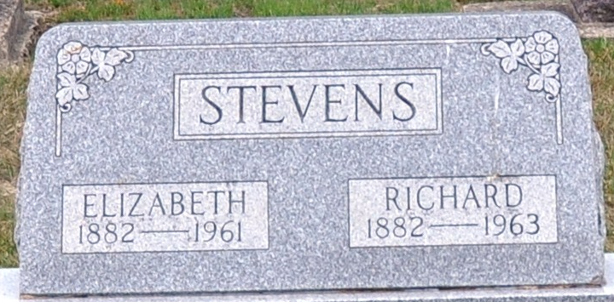
Photo by Deb Curry

Richard Samuel Stevens
in the Indiana, U.S., Death Certificates, 1899-2017
Name Richard Samuel Stevens
Gender Male
Race White
Marital Status Widowed
Age 80
Birth Date 9 Dec 1882
Birth Place Indiana
Death Date 5 Aug 1963
Death Place Fort Wayne, Allen, Indiana, USA
Death Registration Date 1963
Father Henry Stevens
Mother Martha Debolt
Informant Chalmer Stevens; son; Decatur, Indiana
Burial August 8, 1963; Decatur Cemetery; Decatur, Indiana

