Matie Mae (Chronister) Stevens
March 15, 1891 – October 11, 1945

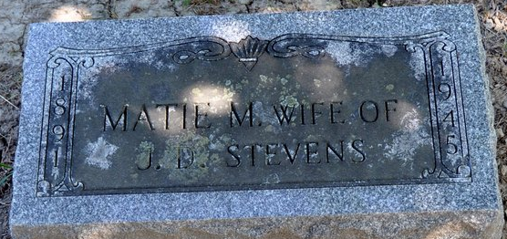
Photo by Deb Curry

Matie Stevens
in the Indiana, U.S., Death Certificates, 1899-2017
Name Matie Stevens
[Matie Chronister]
Gender Female
Race White
Marital Status Widowed
Age 54
Birth Date 15 Mar 1891
Birth Place Adams County
Death Date 11 Oct 1945
Death Place Decatur, Adams, Indiana, USA
Death Registration Date 1945
Father Albert Chronister
Mother Annis Smith
Informant Donald Stevens; Decatur, Indiana
Burial October 13, 1945; Decatur Cemetery; Decatur, Indiana

