Martha Ann (DeBolt) Stevens
August 10, 1863 – January 30, 1915

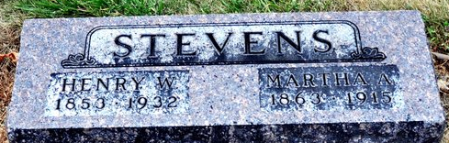
Photo by Deb Curry

Martha Ann Stevens
in the Indiana, U.S., Death Certificates, 1899-2017
Name Martha Ann Stevens
Gender Female
Race White
Marital Status Married
Age 51
Birth Date 10 Aug 1863
Birth Place Indiana Adams Union
Death Date 30 Jan 1915
Death Place Decatur, Adams, Indiana, USA
Death Registration Date 1910-1919
Father Abraham DeBolt
Mother Susan Fredline
Spouse Henry Stevens
Informant Edwin Stevens; Fort Wayne, Indiana
Burial February 1, 1915; Decatur Cemetery

**
Will of Martha A. Stevens

Martha A. Stevens Of Decatur; makes her last will & testament Aug. 17, 1914
Henry W. Stevens Husband; receives 1/5 of life insurance policy proceeds
Richard Stevens Son; receives portion of life insurance policy proceeds
Viola Stevens Daughter; receives portion of life insurance policy proceeds
Edwin Stevens Son; receives portion of life insurance policy proceeds
Clarence Stevens Son; receives portion of life insurance policy proceeds
Ada Stevens Daughter; receives portion of life insurance policy proceeds
Henry W. Stevens Husband; shall have use of household goods, property, jewelry, etc.
Clarence Stevens Son; shall have use of household goods, property, jewelry, etc.
Ada Stevens Dau; shall have use of household goods, property, jewelry, etc.
Viola Stevens Dau; shall have use of household goods, property, jewelry, etc.
Ada Stevens Dau; shall share remaining personal goods after death of Henry Stevens
Viola Stevens Dau; shall share remaining personal goods after death of Henry Stevens
Henry W. Stevens Husband; shall inherit 1/3 of real estate; children to inherit 2/3
Henry W. Stevens Husband; appointed executor of will of Martha A. Stevens
Jesse C. Sutton Witnessed Martha Stevens making her last will
Chas. S. Niblick Witnessed Martha Stevens making her last will
Martha A. Stevens Died Jan. 30, 1915
Jesse C. Sutton Subscribing witness; oath of death & validity of will

